Task Launch Linux EC2 instances in two regions using a single Terraform file

Code file attached as main.tf

In South Mumbai region

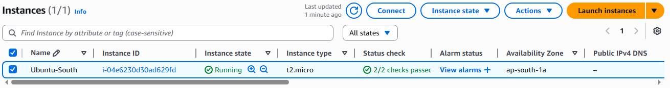

in us-west-2
